Data Base Lab 4 Task
Q1. Use HR Schema
- Display salary increased by 10% for all employees.
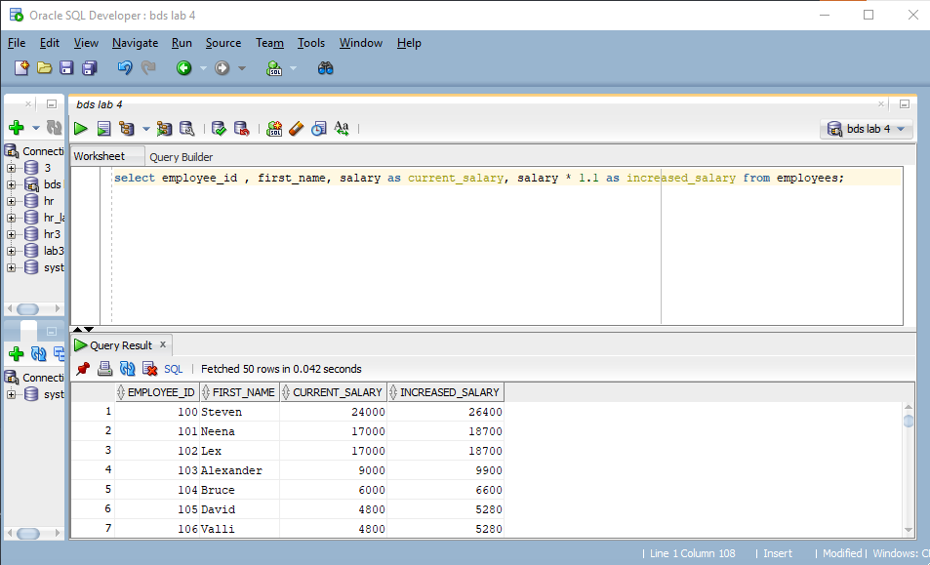
- Display employees where salary > 5000 AND department_id = 50.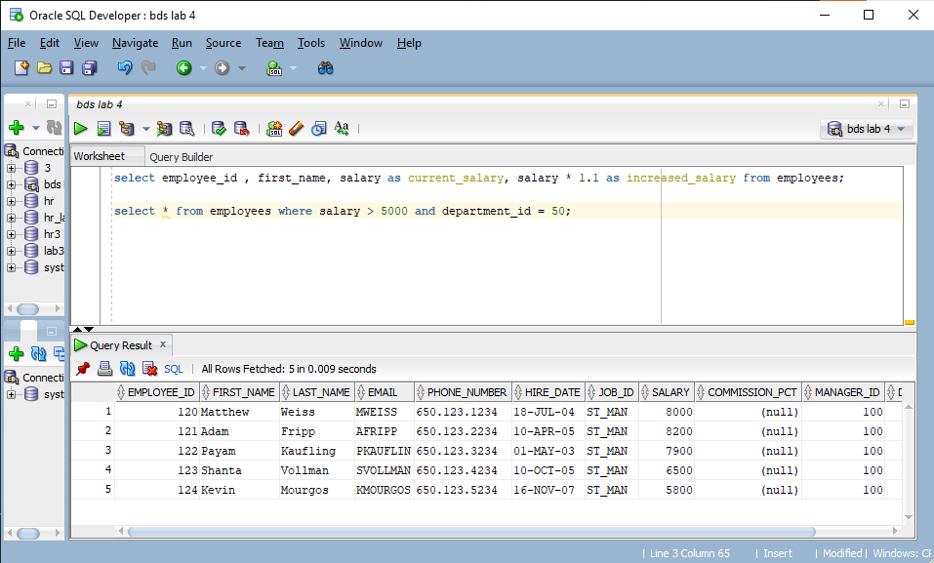
C. Display employees where salary BETWEEN 4000 AND 8000.
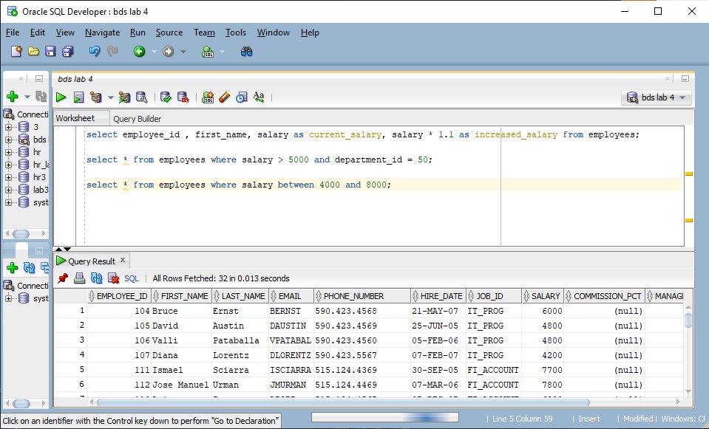
D. Display employees whose first_name starts with 'A'.
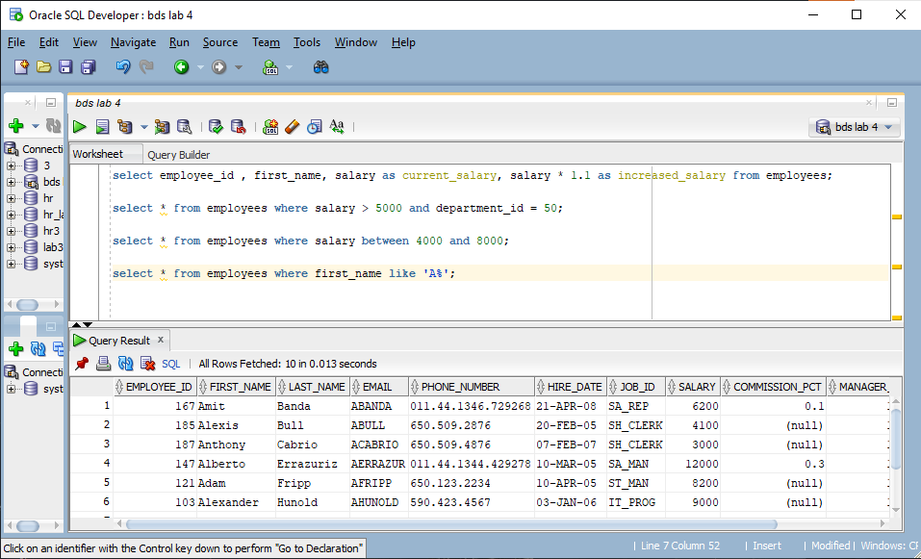
E. Display employees whose department_id IN (10,20,30).
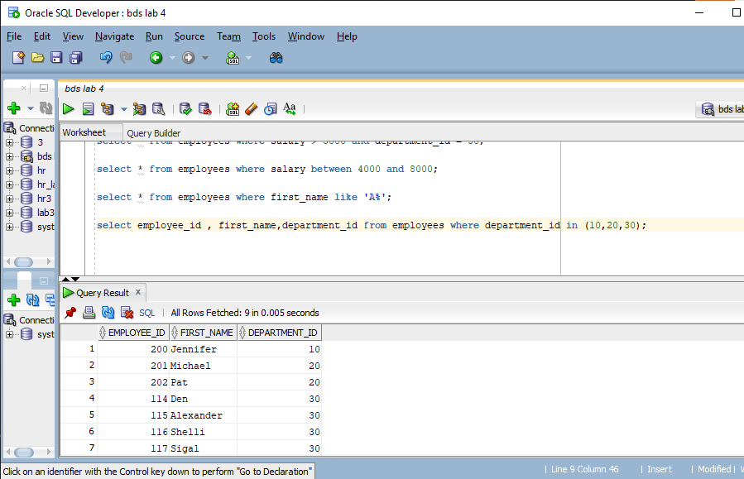
Q2.
- Display employees whose first_name contains 'an'.
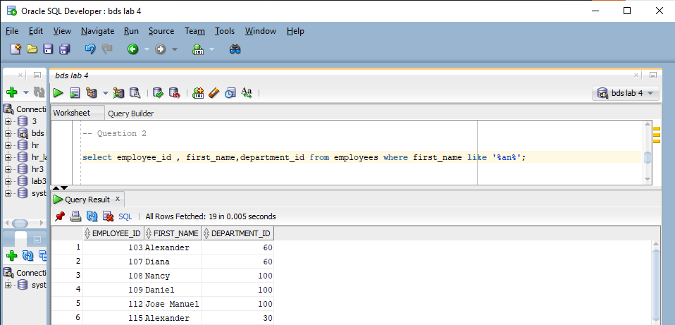
- Display employees ordered by salary DESC
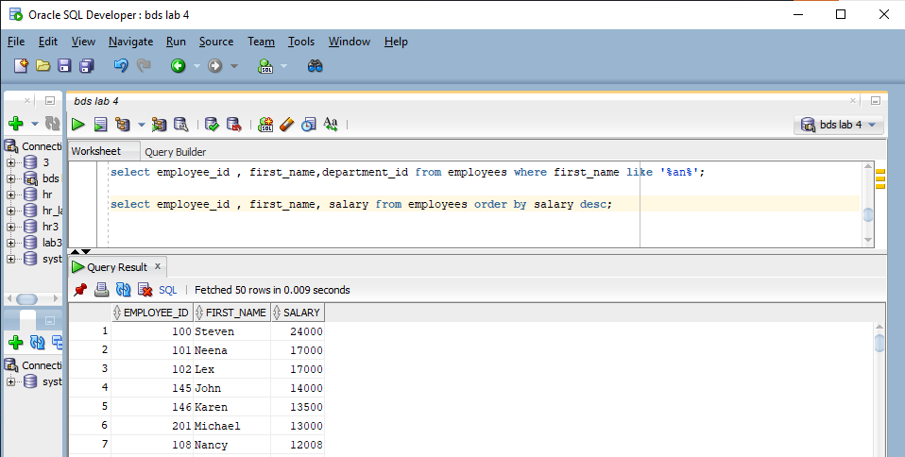
- Display the first 5 employees using ROWNUM.
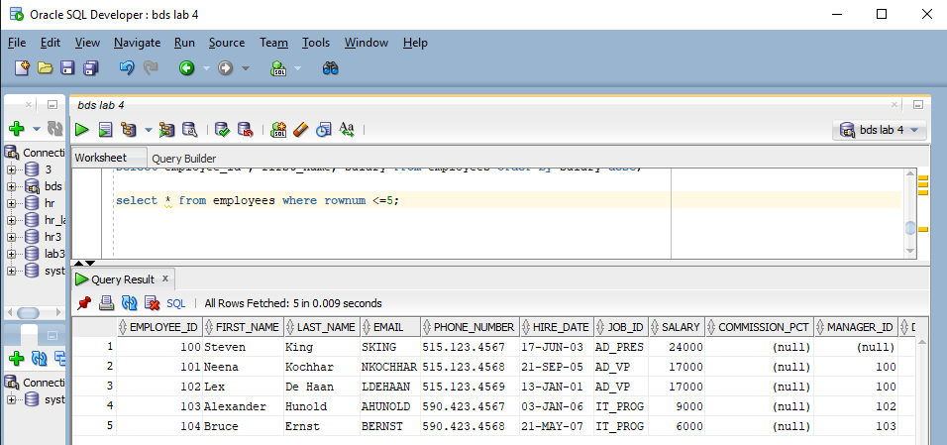
- Display full name using CONCAT or || operator.
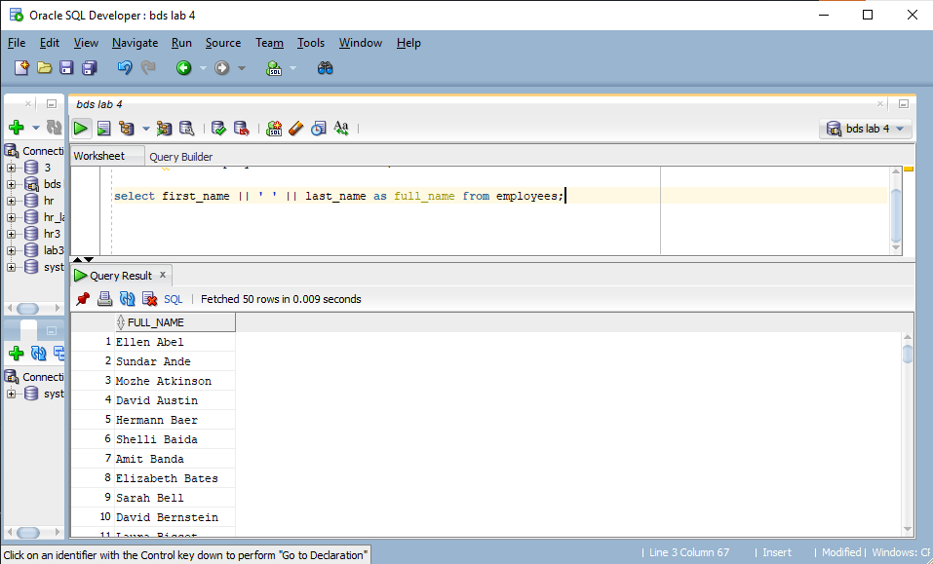
Q3. The HR department wants to standardize employee names:
All names in uppercase || Remove leading/trailing spaces.
Task: Write a query to display cleaned full names using UPPER() and TRIM().
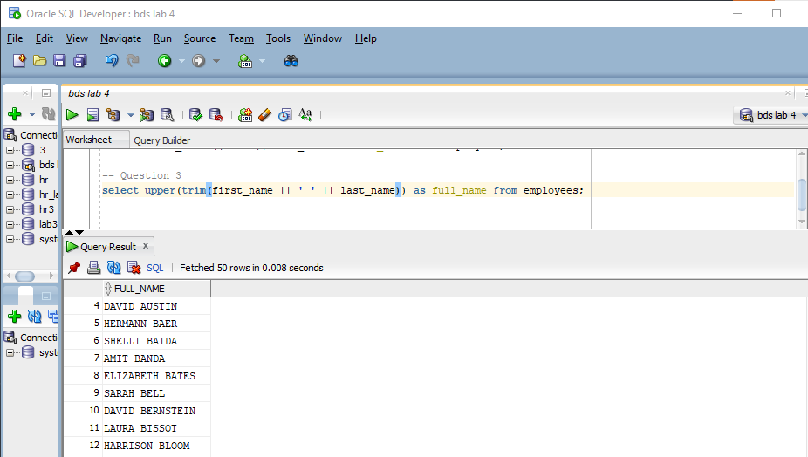
Q4. Company migrated its emails:
Old format: @oldcompany.com New format: @newcompany.com
Task: Write a query to replace all old emails with the new domain using REPLACE().
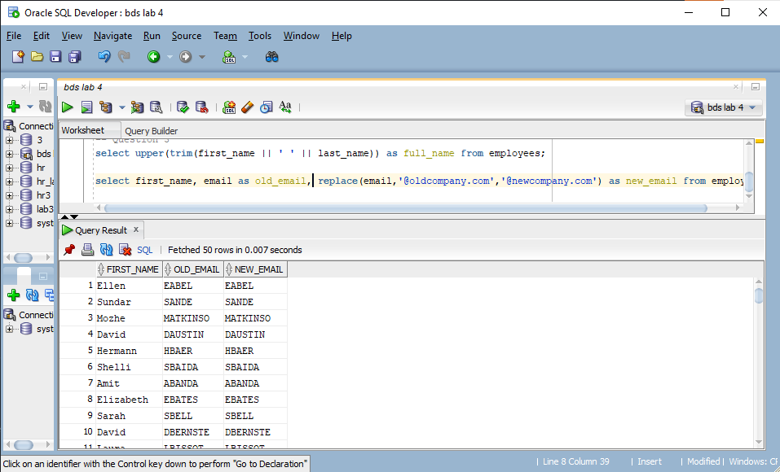
Q5. You need a report of employees:
Name contains 'an'w
Hired between 2010 and 2015
Task: Write a query using LIKE and BETWEEN.
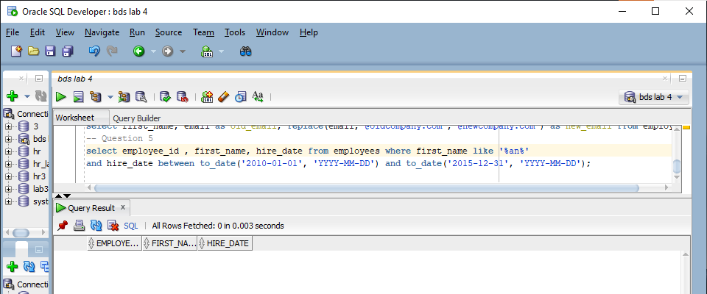
Q6. Finance wants to display salaries:
Rounded to 2 decimals
Formatted with commas
Task: Use ROUND() and TO_CHAR() to display salary as 12,345.67.
